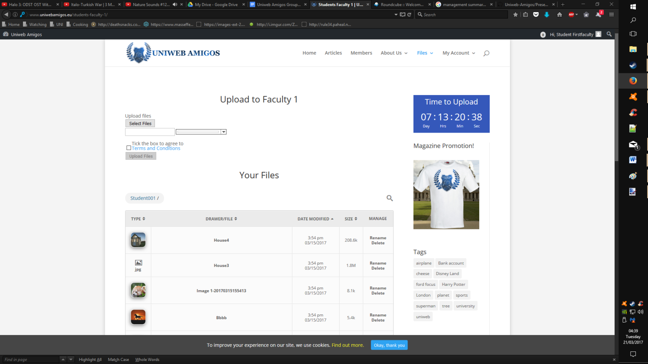Student Functions for Presentation

* 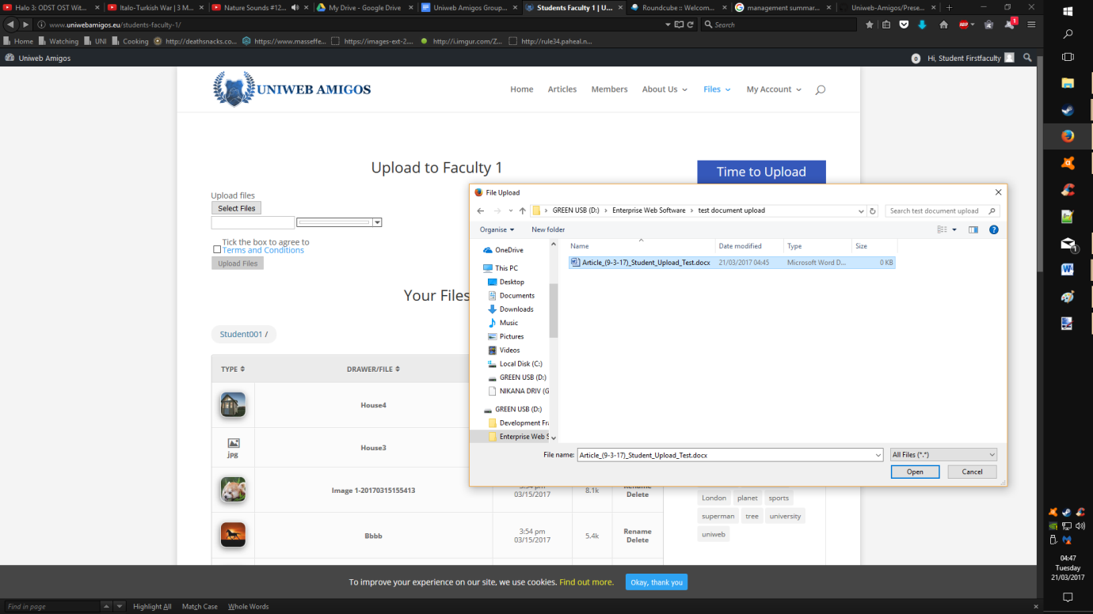On login a student, user is presented with activity screen for uploading files to the system, along with all files that the user has uploaded in a table.
* Choosing the select files option enables report document uploads, but can only be submitted for approval by a coordinator by checking the terms and conditions box, doing so unlocks the upload button.

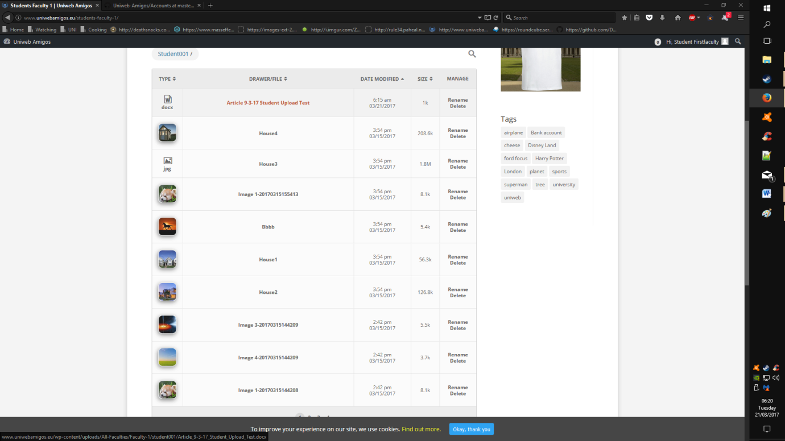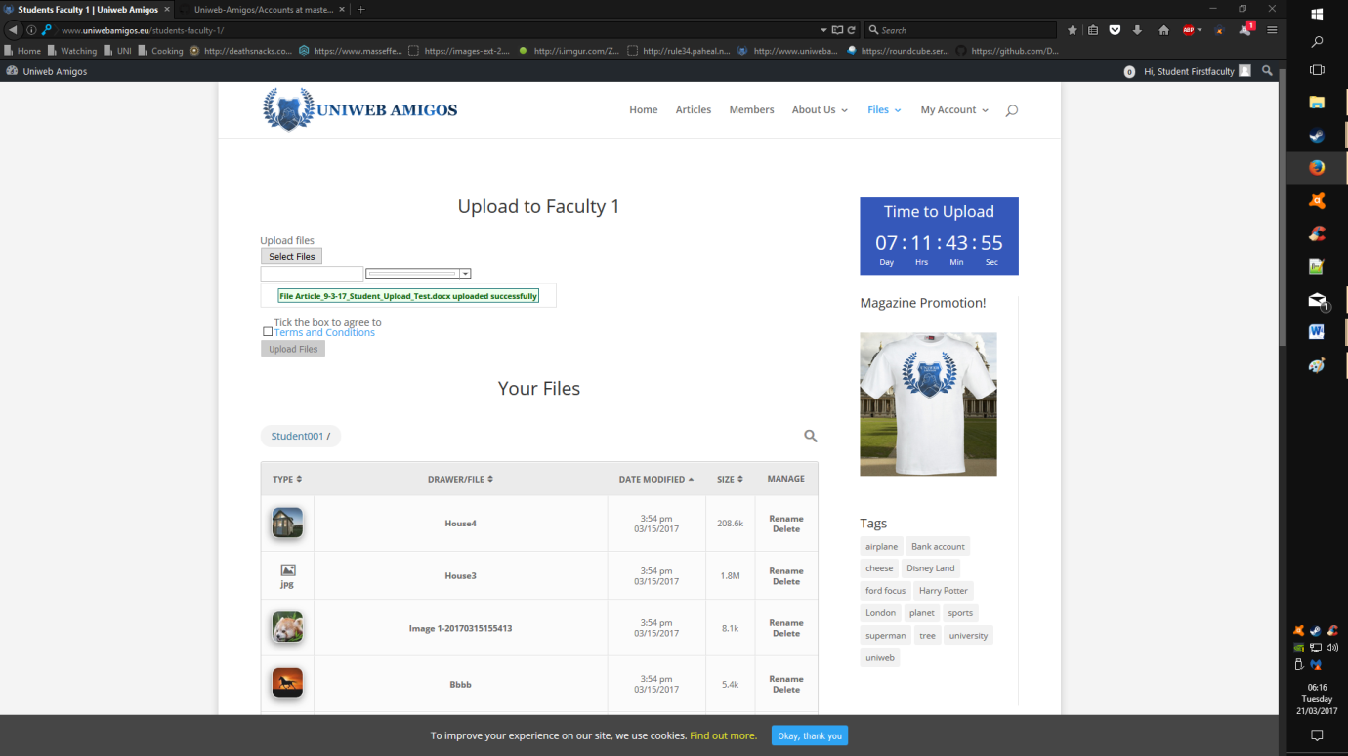

* The file has been successfully uploaded; currently the file in question is missing from the list below, refreshing the page will reload the list to display the new upload.

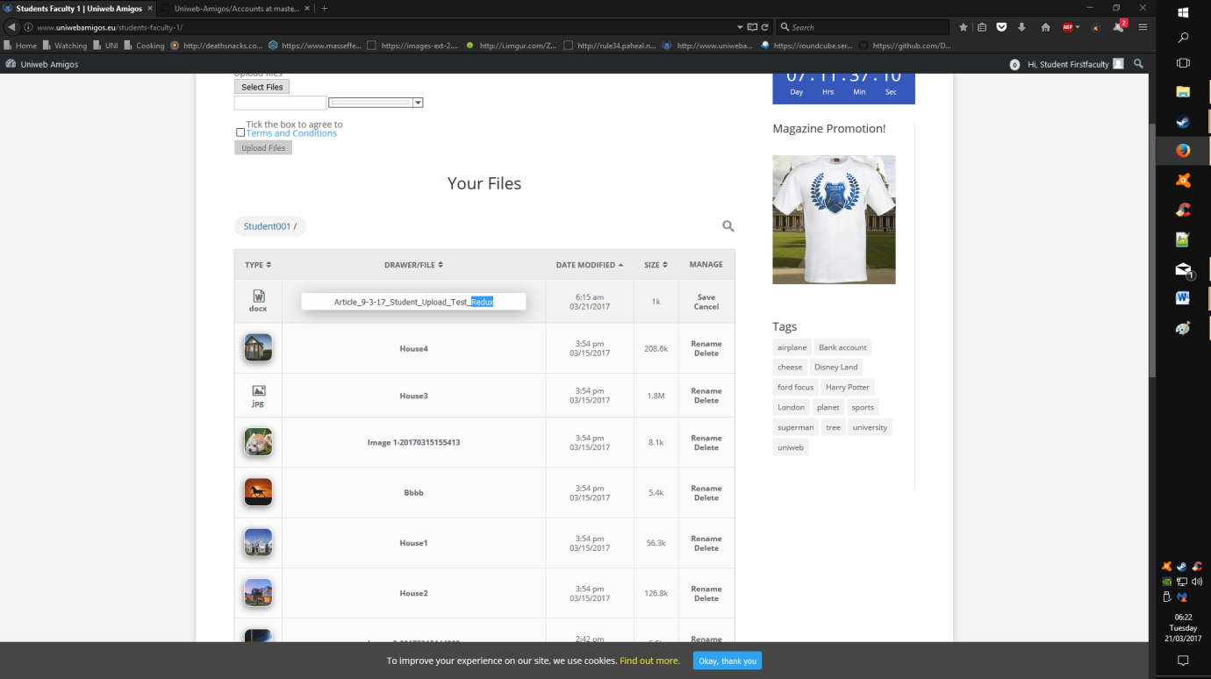

* The user uploads list provides the opportunity to rename and delete files from their library.

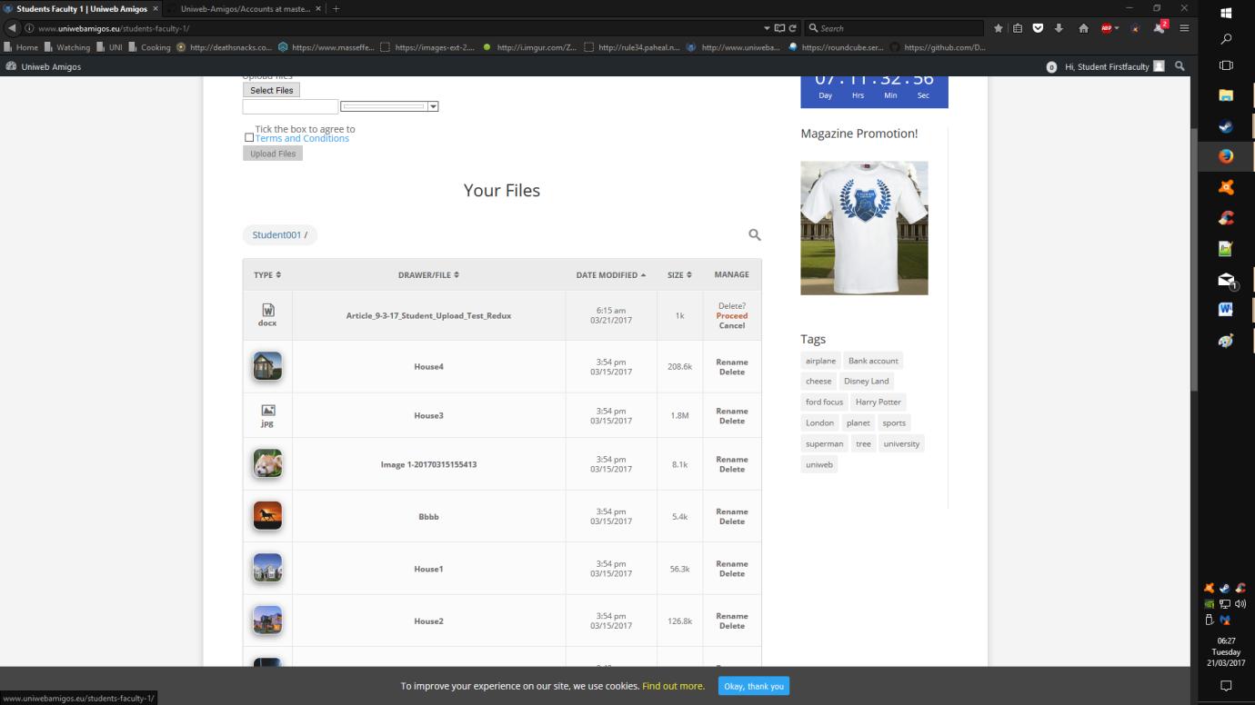

* Confirmation of a deletion is required before the item is removed from the library.
* 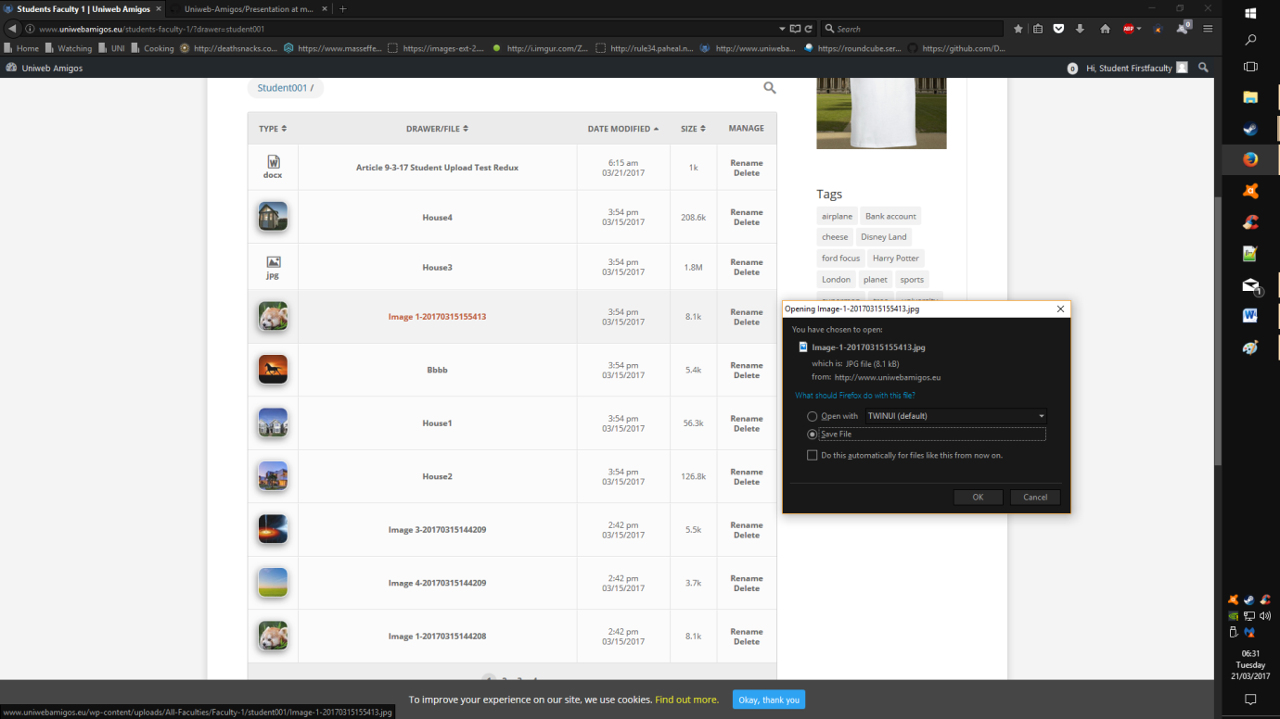The user is able to view currently hosted uploads by downloading them from the list; clicking either the name, or the thumbnail facilitates this.